Sensitivity analysis of Savannakhet model

# Introduction

We explored the effect of each intervention and its parameters on the outcome of the submitted Savannakhet model to find out how we could achieve the maximum impact from the interventions. During the process, we also discovered that the way we modelled the vaccine in the submitted model was not accurate.

We corrected the mistake and explored the sensitivity analysis again. The results are shown in the following sections.

# Univariate sensitivity analysis of submitted model

Out of total 60 parameters of the model, 37 user input-able parameters are tested for sensitivity on incidence (Fig. 1) and prevalence (Fig. 2). Each parameter was take a varied value (either a lower value or a higher value, the values chosen can be seen in Data file 1 and the results in Data file 2).

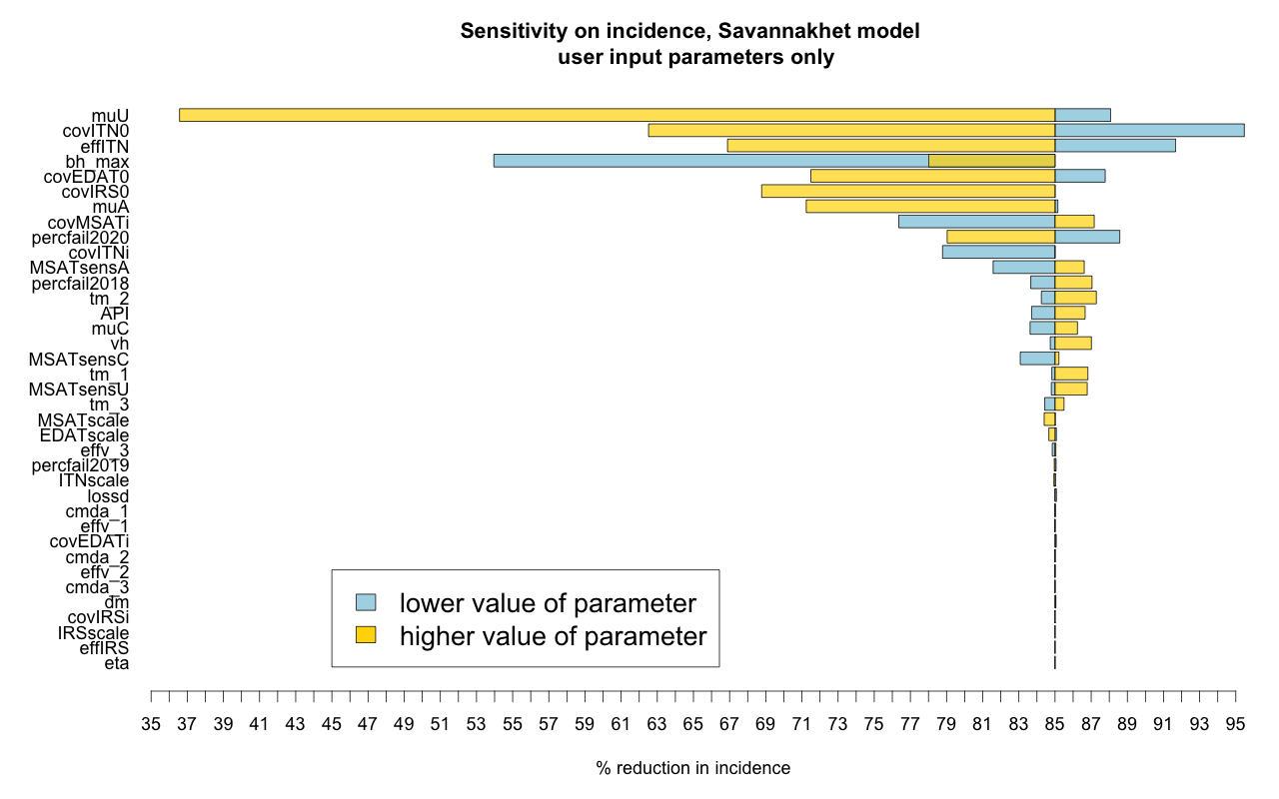

Fig. 1: Sensitivity of user input parameters on % reduction in incidence between 2018 & 2023

~~Both incidence and prevalence are most sensitive to~~ **~~bh_max (# of mosquito bites/human/night), effITN (Effect of LLIN) and case importation parameters (muU, muA, muC).~~**

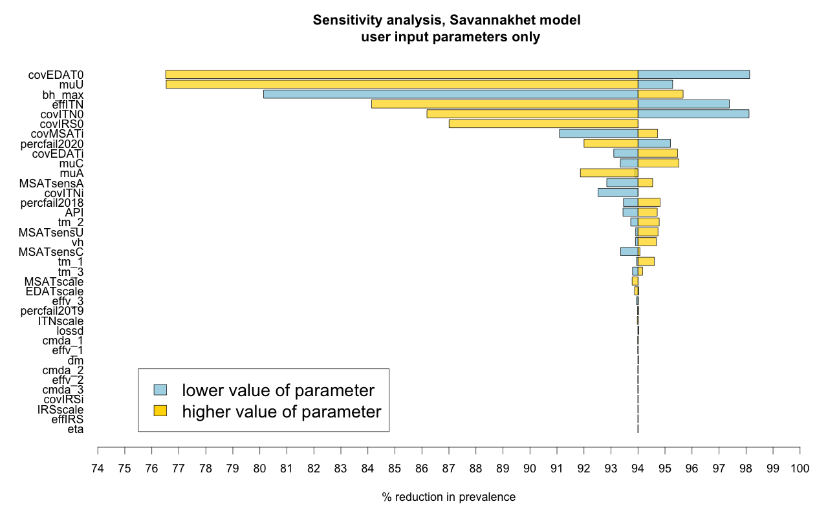

Fig 2. Sensitivity of user input parameters on % reduction in prevalence between 2018 & 2023

# Probabilistic sensitivity analysis of submitted model

We generated 10000 sets of baseline parameter sets from random uniform distributions. Among these, we chose 102 baseline parameter sets that could approximate the baseline malaria status of Savannakhet. We generated 100 intervention parameter sets to pair up with those 102 baseline parameter sets. The timing of MVDA rounds and the effects of vaccine which are incremental over time, are generated based on the random proportions to the lattermost (biggest) value. All other intervention parameters are sampled from a uniform distribution. Interventions are sequentially turned on for each 10200 parameter sets (Data file 3). The mentioned steps can be seen at Fig. 3.

Fig. 3: Steps taken for the probabilistic sensitivity analysis.

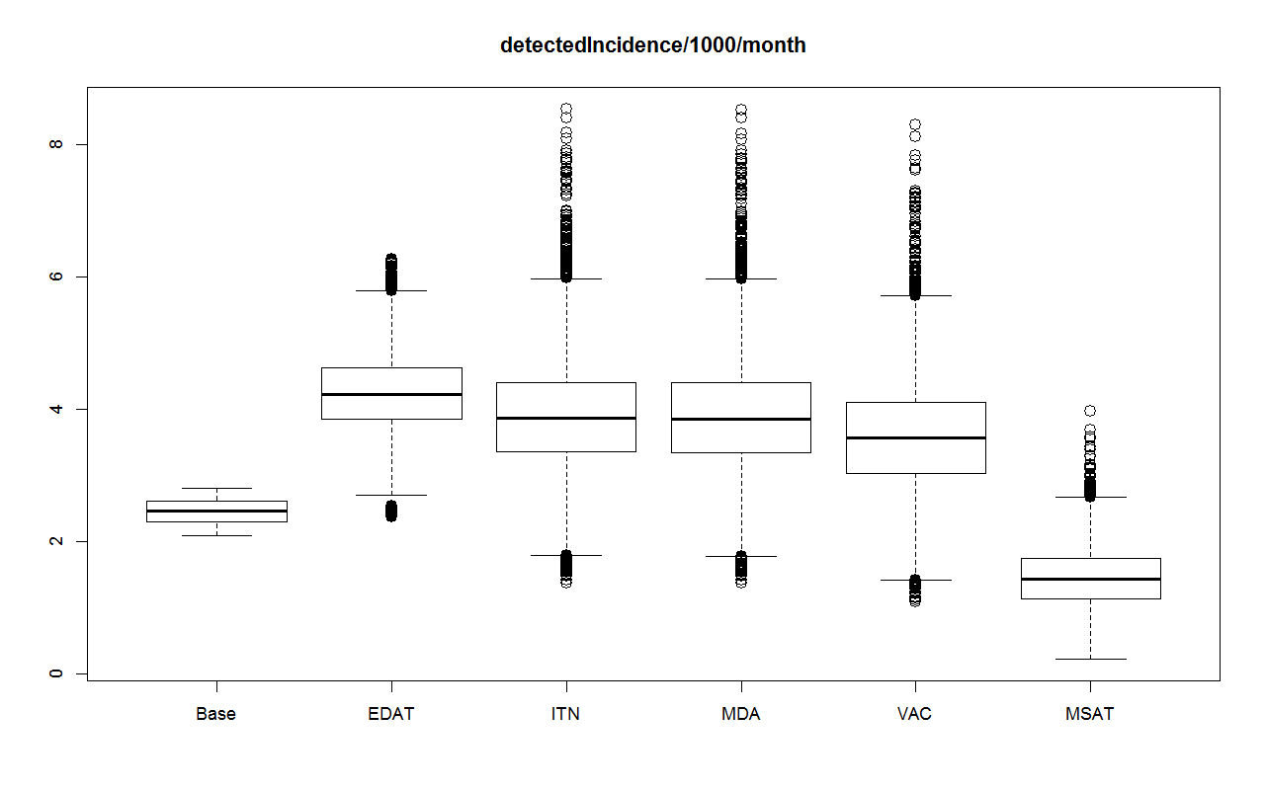

Fig. 4: Sequential effect of interventions on incidence (incidence/1000/month)

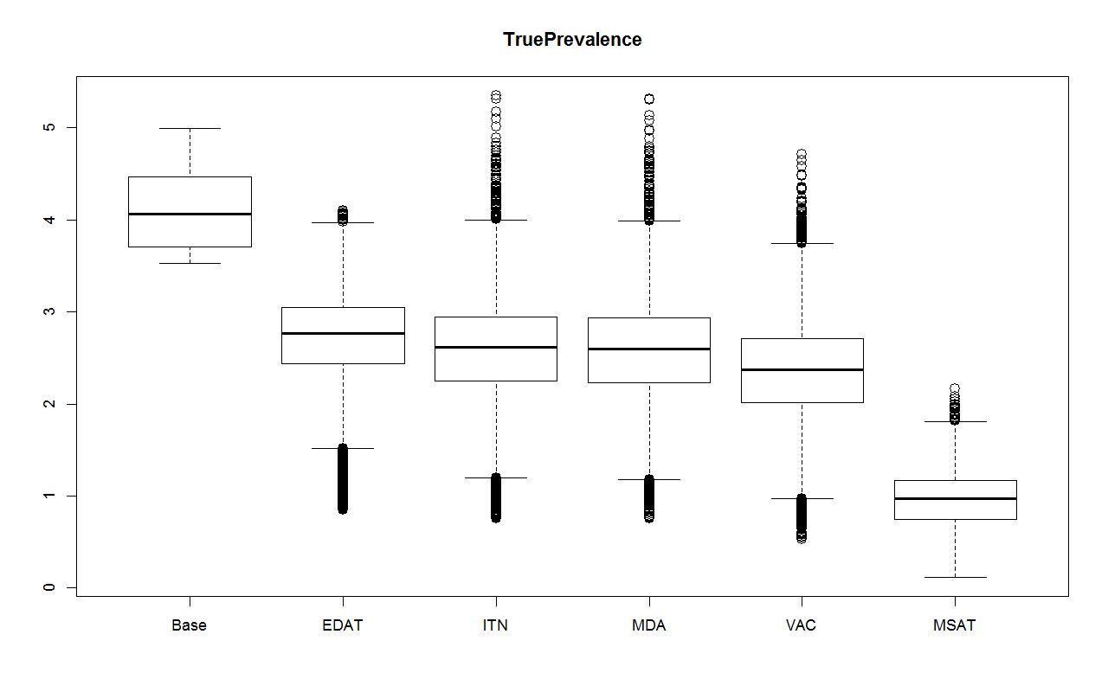

Fig. 5: Sequential effect of interventions on prevalence

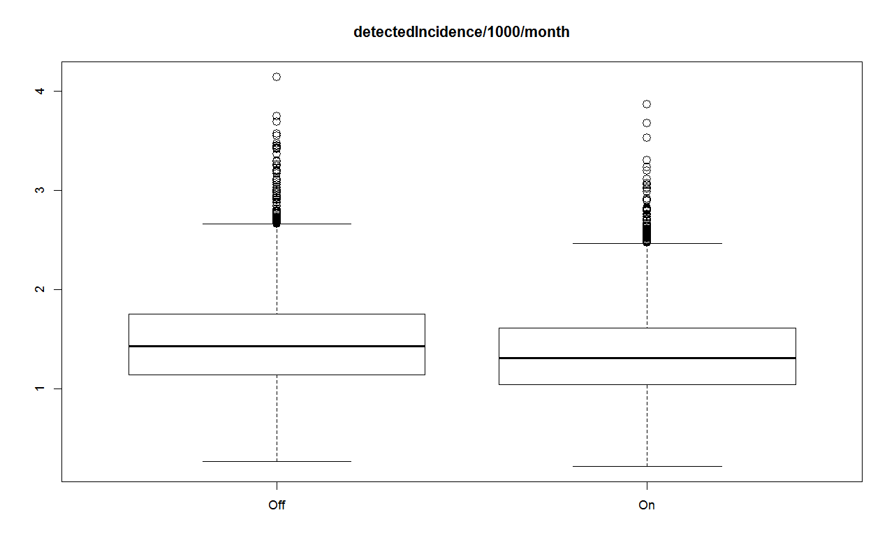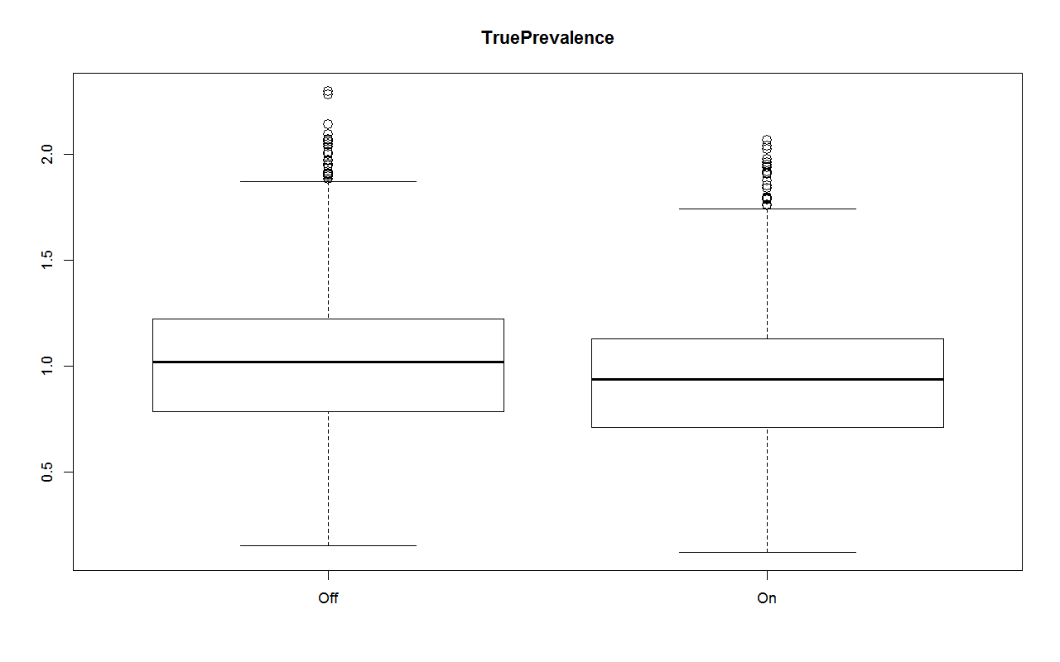

Fig. 6: Additional effect provided by vaccine

By having vaccination, there will be incidence reduction of 0.12 per 1000/month (95%CI: 0.118-0.124) and prevalence reduction of 0.08 (95%CI: 0.078-0.081).

# Findings from sensitivity analysis of the submitted model

Though not of direct finding from the sensitivity analysis, we realized that the vaccine sub-model in the submitted paper has been inaccurate. Instead of vaccinating only those having the MDA rounds, vaccine was given to everyone in the submitted paper, and thus producing more effect of the vaccine than it should be. Even with the overestimated vaccine effect, the vaccine is only having a minimal effect when added to the suite of interventions (Fig. 5). The reason behind this is vaccine and MDA do not have additive effect.

# Modifications to the submitted model

1. Previously, the vaccine was modelled so that everyone (who accepts the vaccine) will be vaccinated, despite the MDA coverage. This has been modified in order to accommodate the following scenarios:
   1. MVDA at hotspots (ie. MDA and vaccine have the same covearage)
   2. MDA at hotspots and vaccination to everyone
   3. Vaccination to everyone without MDA
2. Vaccine sub-model has been changed according to [1]
   1. It takes 2 weeks before a vaccine dose has its maximal effect [2,3]. From the maximal effect, it wanes in a biphasic exponential distribution due to the short-lived and long-lived component of antibodies (Fig. 7). The vaccine effect is now calculated by the set of equations in Appendix.
   2. % protective efficacy of 1st and 2nd doses are assumed to be proportional to the “% protective efficacy of RTS,S with 3rd dose” at 80% and 90% respectively
   3. Subsequently, “% protective efficacy of RTS,S with 1st dose”, “% protective efficacy of RTS,S with 2nd dose” and “half-life of vaccine protection (days)” are removed from the user input parameters.

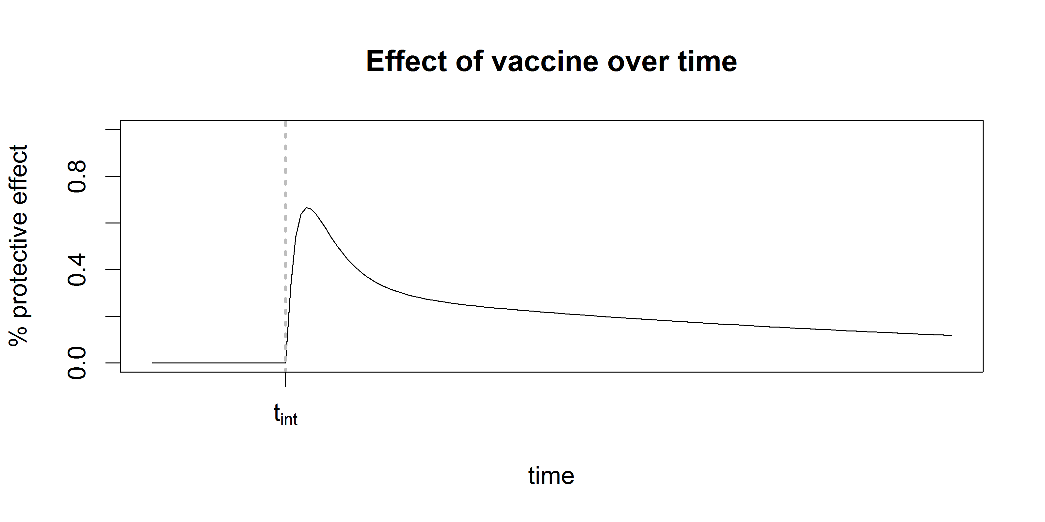  
Fig. 7: Protective efficacy of vaccine

2 weeks before

Max. vaccine effect

Short-lived component

Long-lived component

# More scenarios in the new model

This is to explore the effect of vaccine based on its coverage. Scenario 1 (Fig. 8) is the proposed strategy (vaccine is given to the same people who get MDA, ie. the population in the hotspots) in the submitted paper. In Scenario 2 (Fig. 9), vaccine is given to people both in and out of the hotspots while MDA is given only to those in the hotspots. Scenario 3 (Fig. 10) models vaccination to both in and out of the hotspots, and MDA is not provided.

From the figures, vaccine doesn’t have additive effect unless the coverage is more than the MDA population. Vaccinating everyone is better than MVDA in the hotspots.

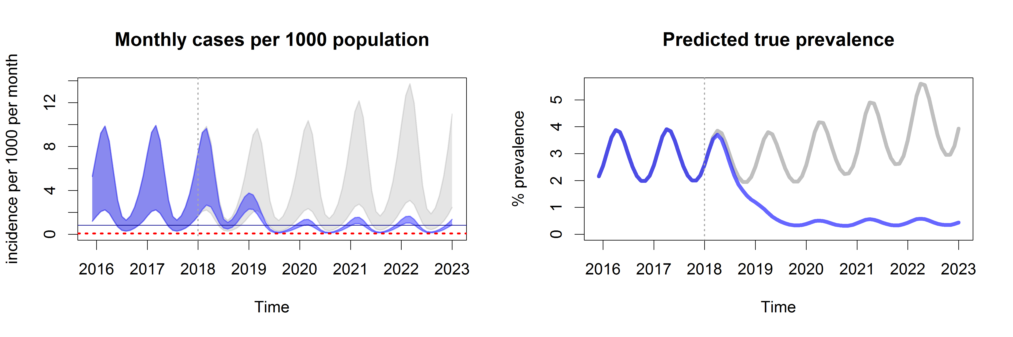

Fig. 8: Scenario 1: MVDA at hotspots (ie. MDA and vaccine have the same covearage)

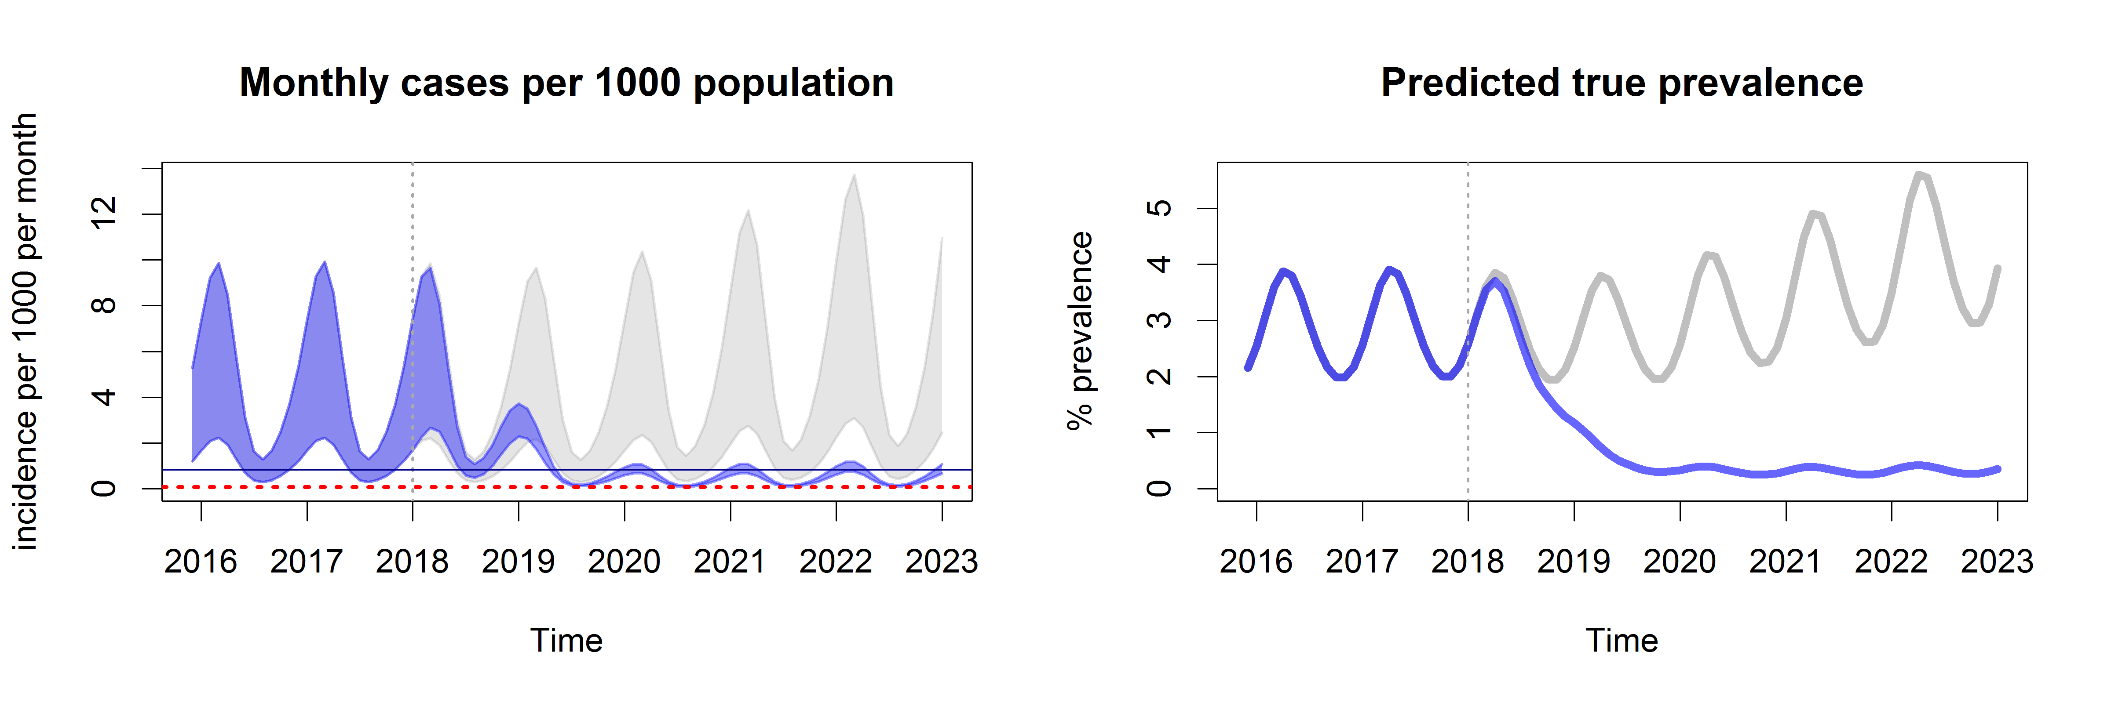

Fig. 9: Scenario 2: MDA at hotspots and vaccination to everyone

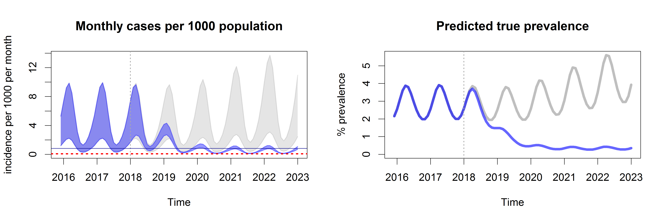

Fig. 10: Scenario 3: Vaccination to everyone without MDA

# Univariate sensitivity analysis of the new model

After updating the model, 39 user input-able parameters are tested for sensitivity on incidence (Fig. 11) and prevalence (Fig. 12). Each parameter was take a varied value (either a lower value or a higher value, the values chosen can be seen in Data file 4 and the results in Data file 5). Sensitivity of vaccine related parameters can be seen on Fig. 13 and Fig. 14.

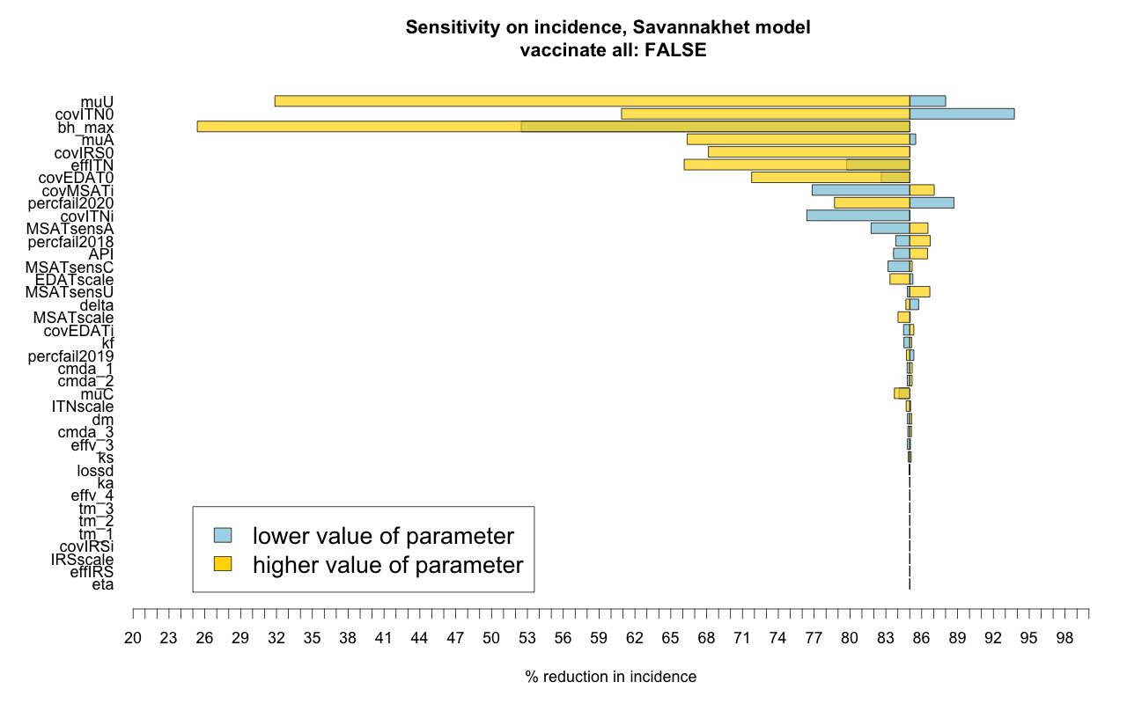

Fig. 11: Sensitivity of user input parameters on % reduction in incidence between 2018 & 2023, new model

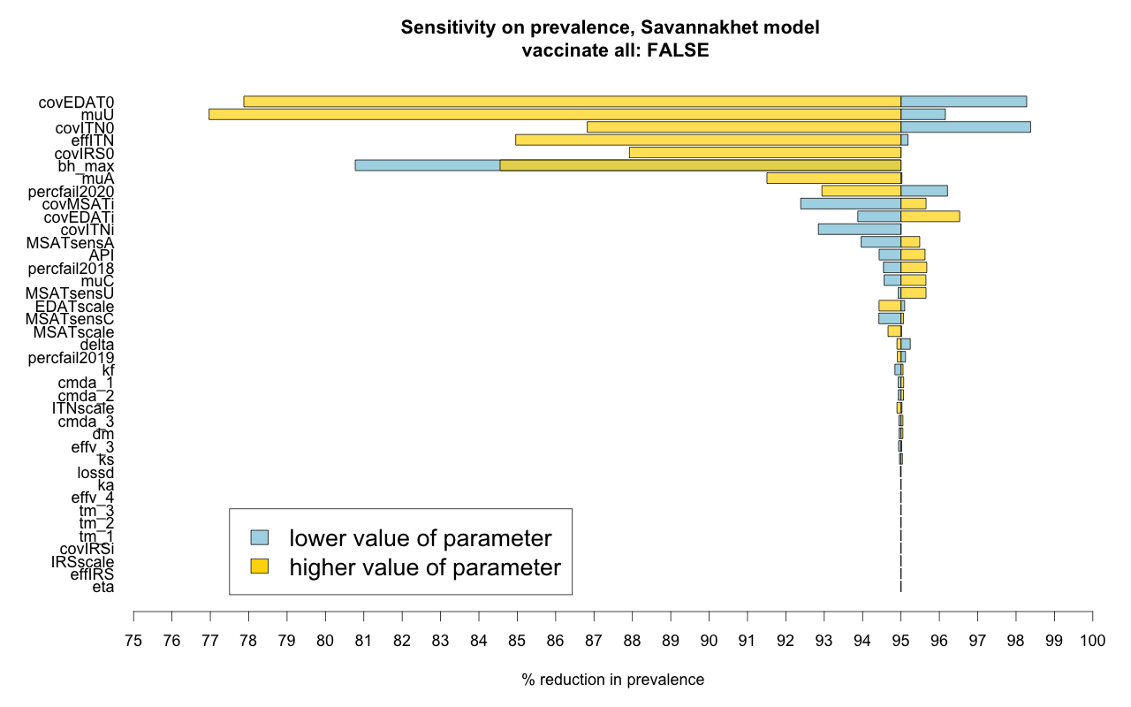

Fig. 12: Sensitivity of user input parameters on % reduction in prevalence between 2018 & 2023, new model

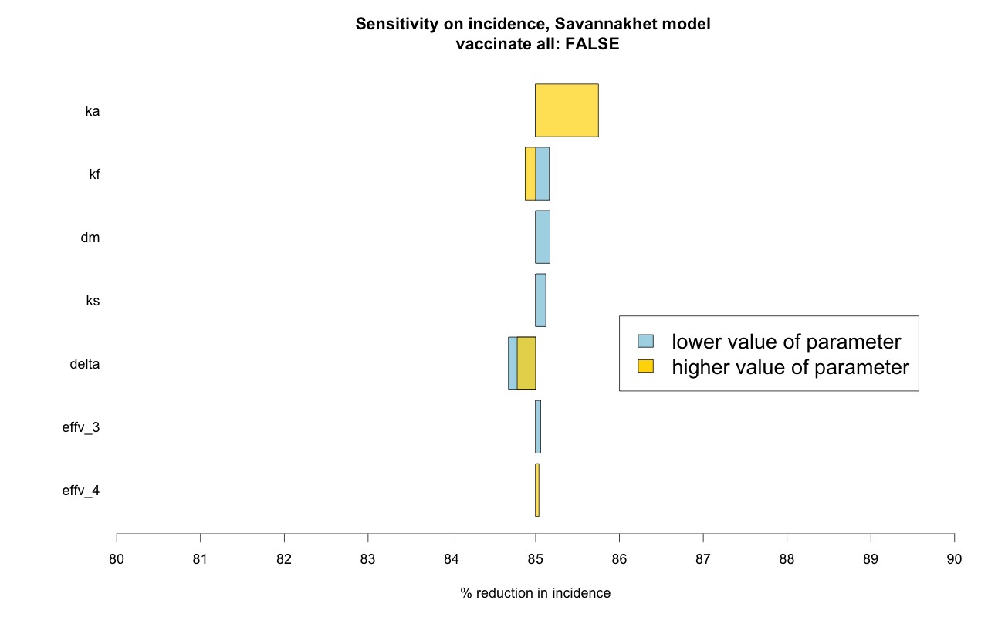

Fig. 13: Sensitivity of vaccine parameters on % reduction in incidence between 2018 & 2023, new model

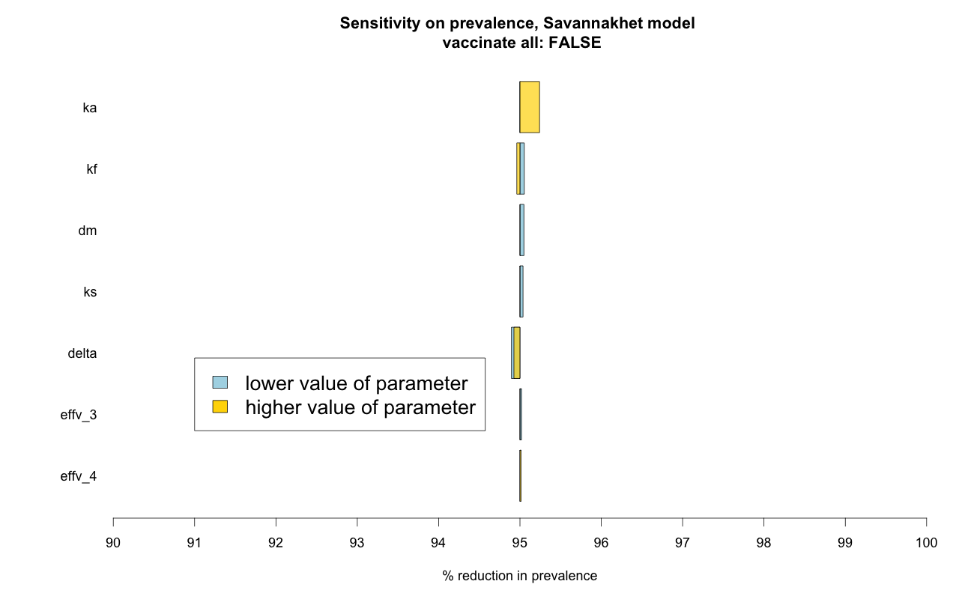

Fig. 14: Sensitivity of vaccine parameters on % reduction in prevalence between 2018 & 2023, new model

# Comparing EDAT+ITN+MDA to EDAT+ITN+MDA+VAC

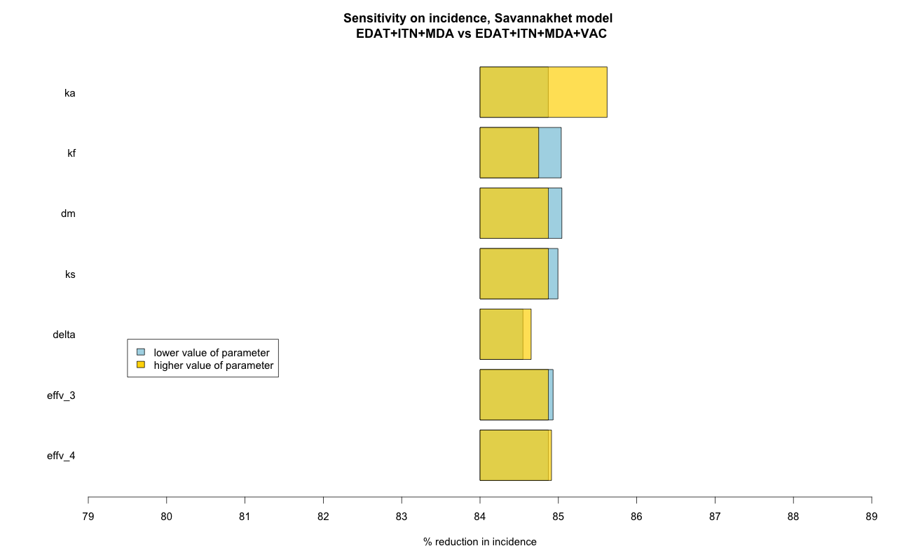

Fig. 15: Comparing EDAT+ITN+MDA to EDAT+ITN+MDA+VAC (% reduction in incidence)

­­­­­­

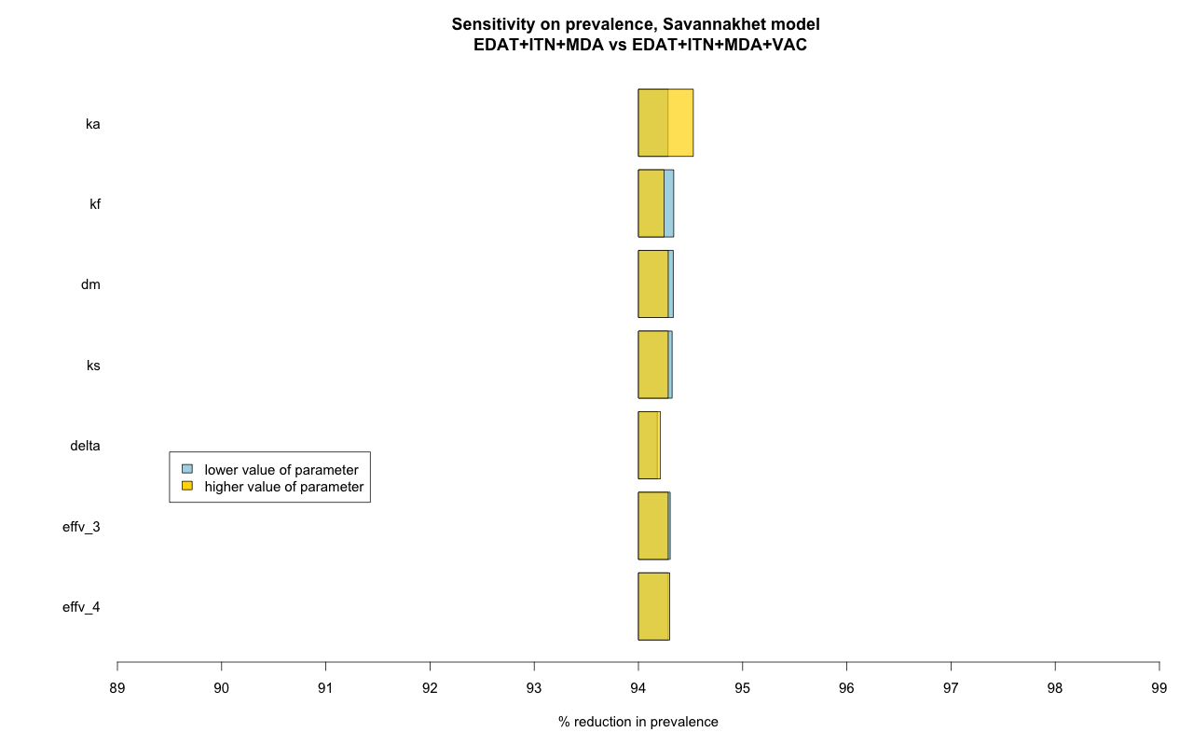

Fig. 16: Comparing EDAT+ITN+MDA to EDAT+ITN+MDA+VAC (% reduction in prevalence)

# References

1. White MT, Verity R, Griffin JT, Asante KP, Owusu-Agyei S, Greenwood B, et al. Immunogenicity of the RTS,S/AS01 malaria vaccine and implications for duration of vaccine efficacy: secondary analysis of data from a phase 3 randomised controlled trial. Lancet Infect Dis. 2015;15: 1450–1458. doi:10.1016/S1473-3099(15)00239-X

2. Stoute JA, Kester KE, Krzych U, Wellde BT, Hall T, White K, et al. Long‐Term Efficacy and Immune Responses following Immunization with the RTS,S Malaria Vaccine. J Infect Dis. 1998;178: 1139–1144. doi:10.1086/515657

3. Kester KE, Cummings JF, Ofori‐Anyinam O, Ockenhouse CF, Krzych U, Moris P, et al. Randomized, Double‐Blind, Phase 2a Trial of Falciparum Malaria Vaccines RTS,S/AS01B and RTS,S/AS02A in Malaria‐Naive Adults: Safety, Efficacy, and Immunologic Associates of Protection. J Infect Dis. 2009;200: 337–346. doi:10.1086/600120

# Appendix